ElderSens Router Wifi Configuration Instructions

Configuration Step

1. To configure ElderSensRouter network, ElderSensRouter and PC must first connect to the same network. ElderSensRouter itself can automatically connect to the wireless network named "SM919" and "zhcfx906" by default. So before configuring, please confirm that you have opened the hotspot or WiFi that sets the wireless network name to the "SM919" password as "zhcfx906".
2. After setting up the WiFi environment, connect the ElderSensRouter to the power supply, and set up your PC connection network.
3. Get the IP address of ElderSensRouter.

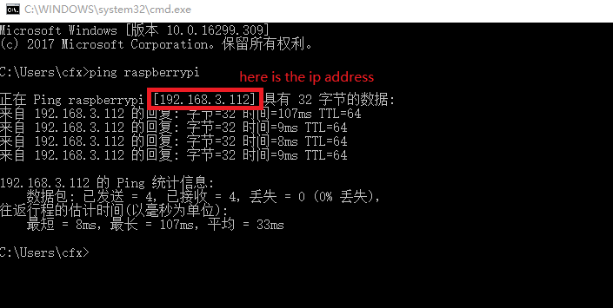Open the command line window of the windows system PC, enter the command "Ping raspberrypi", and get the IP address after receiving the response data. As shown in the following figure.

1. On the PC side, open the putty software, input the IP address from the previous step, connect EldersSensRouter.

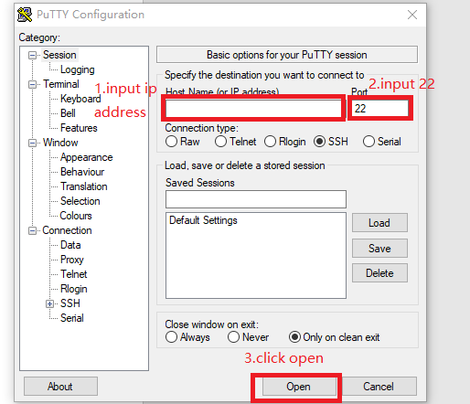

1. When SSH connects to ElderSensRouter, it will ask for input account and password, enter the account name "HK", and password "hkhkhk".

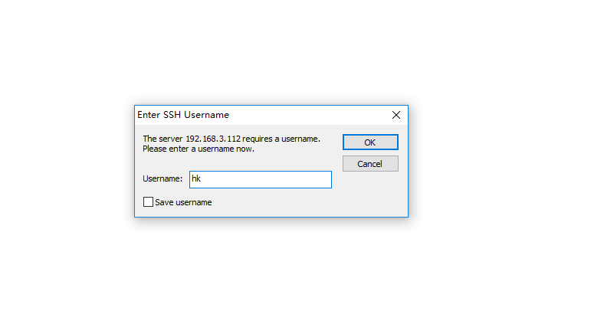

1. After entering the account, you can enter the command :

"vi /etc/wpa_supplicant/wpa_supplicant.conf" then click enter,to enter the configuration file to configure the network.

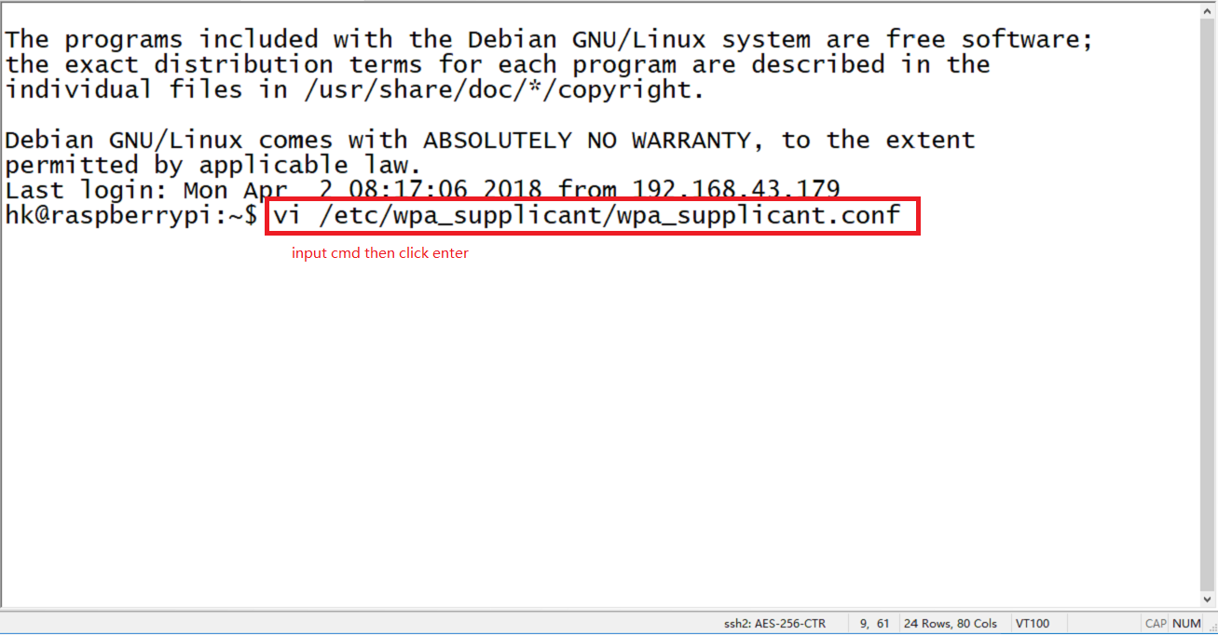

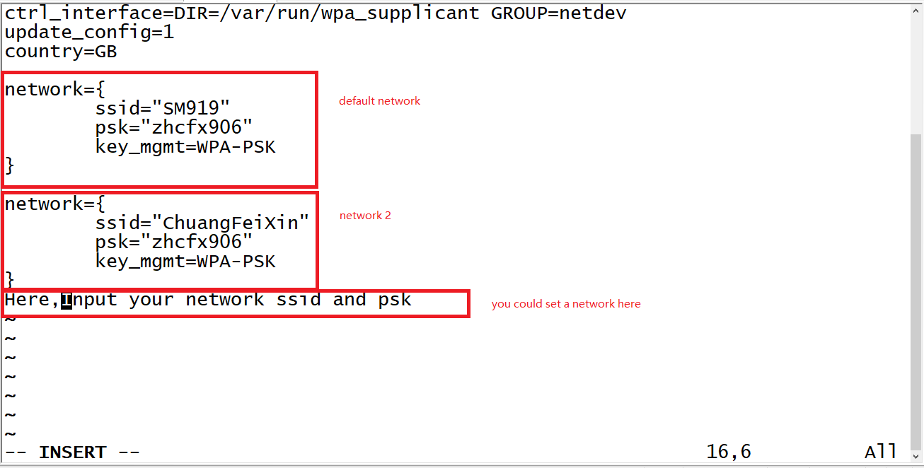(7) After entering the configuration file, click the keyboard key I into the edit mode, you can see that the configuration file has set up several networks. After the edit is completed, click the keyboard Esc button, and then enter ":wq" to save and exit.

1. After that, we will go back to the command line mode, enter the command "sudo reboot", and confirm that ElderSensRouter will be restarted. After restarting, the network will be automatically set up according to priority.

Be careful

Please save the default network, so that it can still reset after the network settings are wrong.